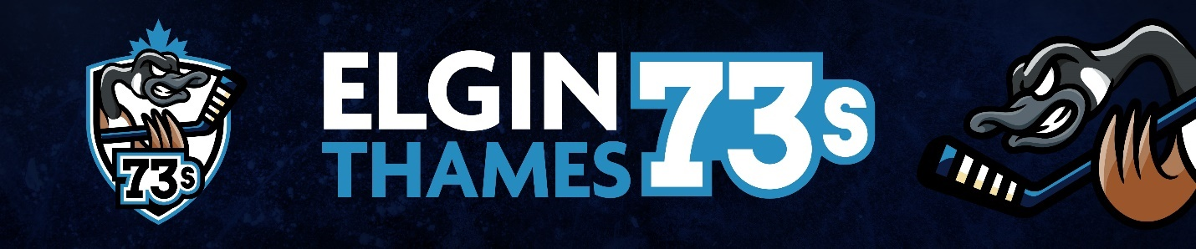
Team Funding / Sponsorship
Hi everyone, as we continue on the path to our inaugural year of the Elgin Thames 73s, we are excited to roll out our new team/player sponsorship program. The intent of this program is to lower the costs associated with hockey for all players and parents and give local businesses an opportunity to support the community.
The sponsorship program is a new format to all three associations and is closely aligned with what some other associations have been doing for the past years.
The funding from sponsorships will come in the form of either a team sponsorship or player sponsorship.

Team Sponsorships
Each team will solicit a team sponsor in the amount of $3500. This will be the primary sponsor for the team. In return for their generous donation, the team sponsor will be the predominant logo on the team banner and website and be represented on ice with helmet stickers of the sponsor logo. We may look at jersey options as well but this would need to be removable as jerseys will be used by players for multiple years as a cost saving initiative.
The team sponsorship amount will be divided equally among the players and added to their player accounts.
Additional team sponsorships can also be sought out, these logos will be on the website and team banner as well with a minimum sponsorship of $500. Teams can also look to get sponsorships for Team apparel including but not limited to Bags, Warm up suits, Hats, Hoodies, T-shirts and Water bottles.

Player Sponsorships
In addition to team sponsorship, each individual player can go out and get sponsorships. These sponsorships are a minimum value of $250, however the sponsor can submit a larger amount if they wish. In return for sponsorship, the logo will be included on the team banner and under each player on the team website.
The players sponsorships funds will be added to the players individual account and will be in place of team fees. Note that if a player chooses not to seek sponsorship, the team fee set by the team can be paid by the parents and will forego their dedicated areas on the banner if they so choose.
Each team expenses will be divided equally among players and deducted from their player accounts and a statement will be provided to parents on a regular basis or upon request.
At the end of the year, any remaining funds in the players account will be returned to the parents.

Player Account Example
If a team sets their annual team fee at $600 per player and receives a team sponsorship of $3500 – the following would be examples of two different player accounts.
Assume player A collects the $600 in sponsorship funds, player B collects $950 in sponsorship and player C collects $1000 and parents pay $250 and player D collects $2500.
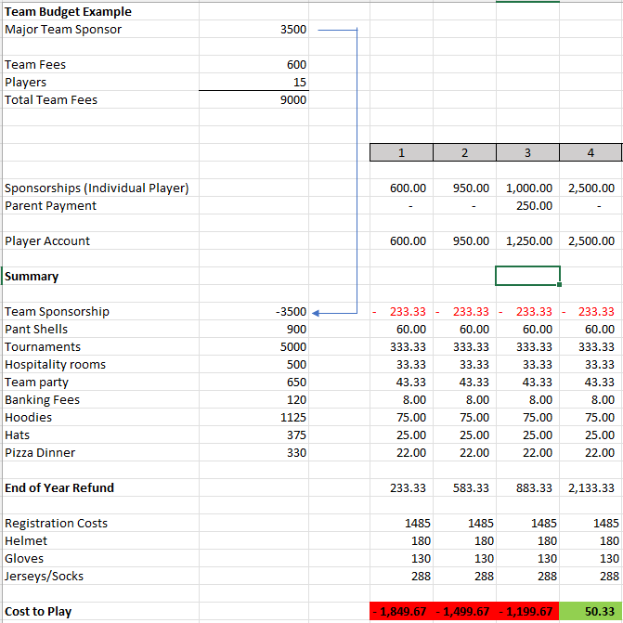
In the above example, you can see that all 4 players receive end of year refunds because of the team sponsorship or parent payment, however those that received more sponsorship actually receive a refund in excess of the original team fee which in turn goes back to the parent and in essence lowers the cost of registration and could covers equipment costs as well.

Purpose
The purpose of this program is to entice parents and players to seek sponsorships which can lower the cost of player hockey for the Elgin Thames 73’s. If parents, grandparents, or friends of the family have companies and are willing to sponsor, the result is lowering the price for players to pay rep hockey, while giving companies the ability to deduct their sponsorships from their corporate taxes.
In the event a parent chooses to not seek sponsorship, it is no different from any past seasons in which parents pay the team fees over and above their registration fees.
We feel that the above program will provide the best of both worlds. Team sponsors can still be sought out and funds distributed equally to the players on the team. In addition, for those sponsors that want to specifically give to an individual player can do so.

If you have any questions on or concerns regarding the above program, please reach out to the Elgin Thames Minor Hockey board at president@elginthamesminorhockey.ca

Thanks,
Shawn Pede, President AMHA Mark Landon, President BMHA Garrett Hamilton, President DMHA

